***Name: Muneeb Raza (p17-6149)***

***Name: M.Ahmed Arshed (p17-6099)***

***Section: CS17-A***

***Railway System***

**Entity Relationship Diagram**

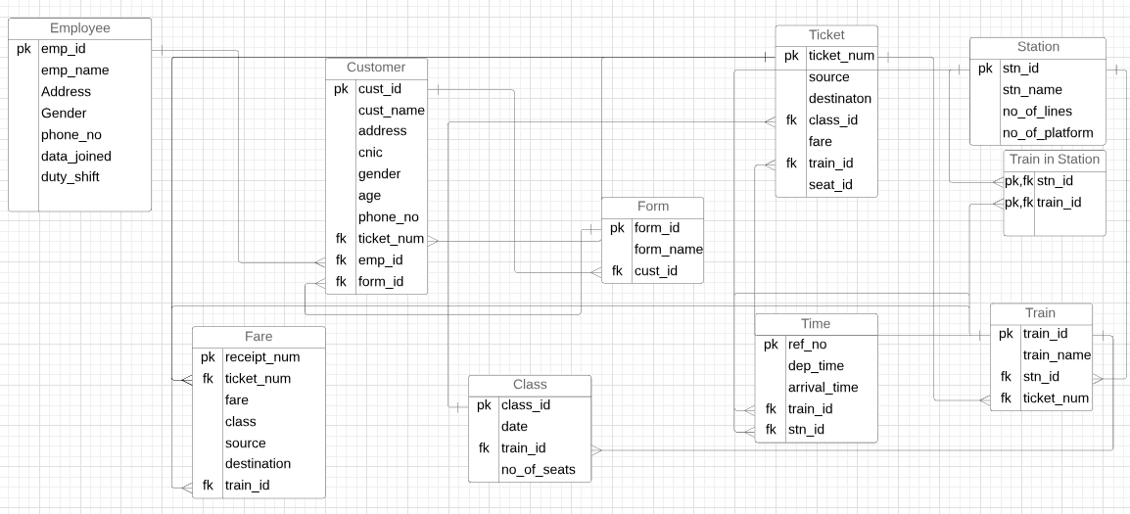

**Normalization**

**Unnormalize form:**

Emp_name , Emp_id , Address , Gender , phone_no , data_joined , Salary , Designation , duty_shift , customer_name , customer_id , cus_address , age , gender, phone_no , ticket_num , source_destination , class , Fare , Train_id , Seat_id, station_name , no_of_lines , station_id , no_of_platforms, train_name , train_num, form_id , form_name , date , no_of_seats , class_id,

source , destination , fare , receipt_num, ref_no , dep_time , Arrival_time

**Normalizing:**

**Table : Employee**

(emp_id , emp_name , address , gender , phone_no , date_joined , duty_shift)

**Emp_id (primary key)**

**Table : Customer**

(cust_id , cust_name , ticket_id , gender , cus_phone_no , emp_id , CNIC , form_id)

**Cust_id(primary key)**

**Emp_id(Foregin key)**

**Form_id(Foregin key)**

**Ticket_id(Foregin key)**

**Table : Ticket**

(ticket_num , source , destination , class_id ,fare , train_id , seat_id)

**Ticket_num(primary key)**

**Class_id(Foregin key)**

**Train_id(Foregin key)**

**Table :Station**

(station_name , no_of_lines , station_id , no_of_platforms)

**Station_id(primary key)**

**Table : Train**

(train_id , std_id , train_name , ticket_num)

**train_num(primary key)**

**station_id(Foregin key)**

**ticket_num(Foregin key)**

**Table : Form**

(form_id , form_name , cust_id)

**Form_id(primary key)**

**cust_id(Foregin key)**

**Table : Class**

(class_id , date ,no_of_seats , train_id)

**Class_id(primary key)**

**Train_id(foregin key)**

**Table:Fare**

(Receipt_num , Ticket_num , fare , class , destination , Source , train_id)

**Receipt_num(primary key)**

**Ticket_num(Foreign key)**

**Table : Time**

(ref_no , dep_time , Arrival_time , train_id , station_id)

**Ref_no(primary key)**

**Tarin_id(Foregin key)**

**Station_id(Foregin key)**